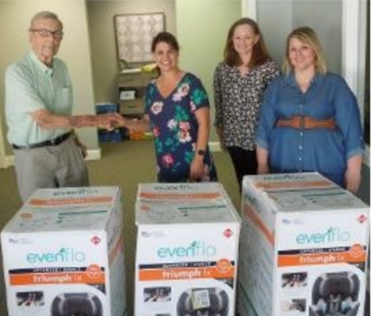

|  |  |  |  |  |
| --- | --- | --- | --- | --- |
| |  |  | | --- | --- | |  |  | |  |  |   ***“Baby Safety Month”*Club Treasurer *Rollin Middlebrooks* and Club member *Crawford Lovet***t **delivered “3” Baby Safety Car Seats to Caring Solutions.**  ***Guest speaker Erica Poulin*** with *Caring Solutions.* The club donated ***“3”*** Baby Safety Car Seats that were delivered to *Caring Solutions* Monday.  The overall program is designed to allow the pending parents to grow and mature in all areas with the goal to becoming a responsible parent through instructional classes, and individual professional counseling, As the pending parents progress through the program, they earn points for successful completion of individual facets of programs of instruction and individual growth.  One of the many facets of the program provided for pending parents has to do with instilling a sense of value, saving, spending – in short, budgeting their personal assets. To give the pending parents practical experience, *Caring Solutions* has created a “store” in which items can be “purchased” with the points the parents earn through participation in *Caring Solutions’* program. The pending parents must make decisions on what to “buy”, the quantities – in short, budgeting their assets to get the best “deals” on the essentials for caring for their, soon to be, new born child. The Baby Safety Car Seats are a prized item for the pending parents. |